5.3.2 Areas Between Polar Curves

Motivation: Suppose we wish to find the area of some region bounded by curve(s) given in polar form. Suppose R is a region bounded by the curves , , and . A picture of a sector (in blue) approximating a portion of R is:

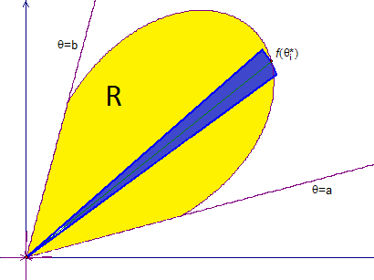
We can approximate the area of the yellow region by using sectors of circles (see the blue region above).

Note: In actuality there would be many sectors drawn over R, and we would approximate the area of R by adding up the areas of all the sectors. The overarching idea is that as the sectors get finer and finer our approximation will approach the area.
Recall that to determine the area of a sector of a circle we can establish the proportion , where A is the area of our blue sector, and is the central angle of the sector (measured in radians). From here we see that

Similar to chapter 2 we assume that each sector used in our approximation has central angle of measure . If the area of the sector above is , we know that . So, if the area of the region R is A we have .

If we let n approach infinity, we recognize the right most sum as a definite integral!

It is therefore reasonable (and in fact can be proven fairly easily in Calculus 3) that
Theorem: If is continuous and either nonnegative or nonpositive for , then the area enclosed by the polar curve () and the lines and is:

Question to the Class: Does the above integral yield a signed area?

Answer: No, it does not. There are many reasons for this. One particularly convincing reason is that the areas of the approximating sectors are always taken to be positive.

Example 1: Find the area enclosed by one of the loops of the four leaf rose given by .

We begin by graphing the region (in yellow):

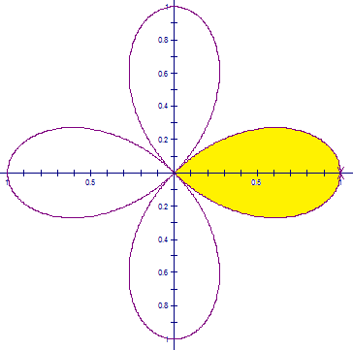

We observe that the first half of the first leaf is traced as varies from 0 to . Thus, the area will be

It is also possible to view the full leaf being traced as varies from to . Thus, the area will be .
Example 2 (you try): Find the area that is shaded in the in the following graph of the curve .

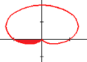
We observe that the shaded region is traced as varies from to .
Thus, the area will be:

Remark: As one would likely expect, if a region R is bounded by the curves with polar equations: , , , and where and , then the area A of R is given by: .

Question: Why do we need f and g to be nonnegative?
Example 3: Find the area of the region that lies inside the curve given by and outside the cardioid given by .

A picture of region (in yellow) is:

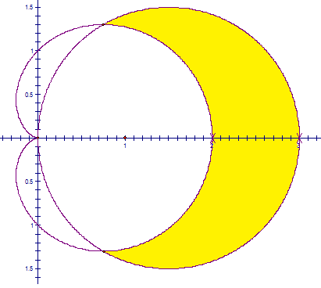

To find the points of intersection we solve . From this equation and the picture we see that the points of intersection are the pole (i.e. the origin), , and . So, the area is:

Example 4 (you try):
Suppose the curve is given by . Also suppose that the curve is given by . Find the area of the region that lies inside both of these curves.

A picture of the region (in yellow) is:

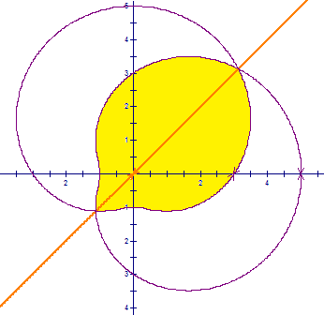

There is also a line in orange drawn which exhibits the symmetry of the region. We note that the points of intersection are and . Thus, the desired area is

It would also to be possible to view the intersection points as and . Thus, the desired area is given by the integral:
Note: We must be careful when determining limits of integration. Certain polar curves, namely roses, can be graphed on different intervals of .

Example 5: Determine how long it takes to trace out the graphs of the roses and .

By graphing on the calculator and adjusting the and under the button we can see that:

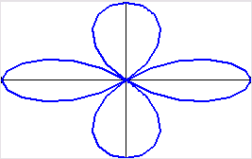
(a 4 petal rose) is graphed
as varies on

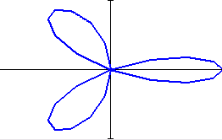
(a 3 petal rose) is graphed
as varies on

Example 6:
- Set up an integral to represent the area enclosed by the entire curve

Here since the graph can be traced once as varies on we set up the integral:

- Set up an integral to represent the area enclosed by the entire curve

Here since the graph can be traced once as varies on we set up the integral:

Note: This subtly of limits is important when working with functions that use negative radii.

